Dear friend,
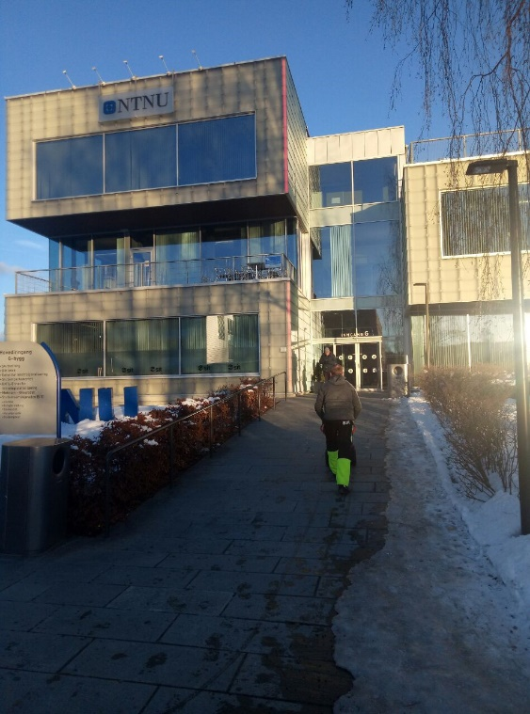
My name is Holubenko Oleksandr, I am a student of the National Technical University of Ukraine "Kyiv Polytechnic Institute" (NTUU "KPI"). And this year I had an opportunity to study one semester at the Norwegian University of Science and Technology, in one of its campuses in the city of Gjovik.
The main purpose of my trip was to feel the life in foreign country, as well as improve my English, which was successfully achieved by one hundred percent.
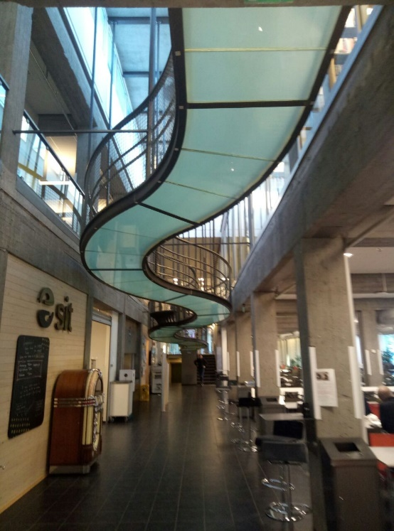
Firstly, I would like to draw attention to the organization of this exchange program - everything was organized on the highest level. Everyone involved in the exchange procedure fulfills its obligations honestly and responsibly.
Teachers from our faculty constantly and timely inform students about existing exchange programs, and Yulia Chernetska advises and provides assistance on any issues, which makes the first stage of filing documents fast and understandable.
Interaction with the partner university is also clear and understandable, I received all the documents necessary for obtaining the visa as soon as possible, the staff of the NTUU academic mobility department accompany and advise the student from the moment they write a letter to the check at the dormitory, and ready to answer any questions.
Receiving a visa was also quick and convenient, the student is required a minimum ammount of documents, and the procedure does not take much time. I received a visa in less than a week.
When you arrive in Norway, the first thing you notice are people - they are very nice, kind and always ready to help. Also, their law-abidingness is felt at once, as many things in Norway are kept on trust to each other, which, of course, very bribes.
Despite the high, in comparison with Ukraine, prices, accommodation in Norway is comfortable, scholarship is enough for a normal life without any worries in everyday life.
The student organization with the support of charitable foundations constantly organises various events, including not only having fun, but also touching the culture and history of other countries. The events are very diverse, from evenings of cinema to hiking in the mountains.
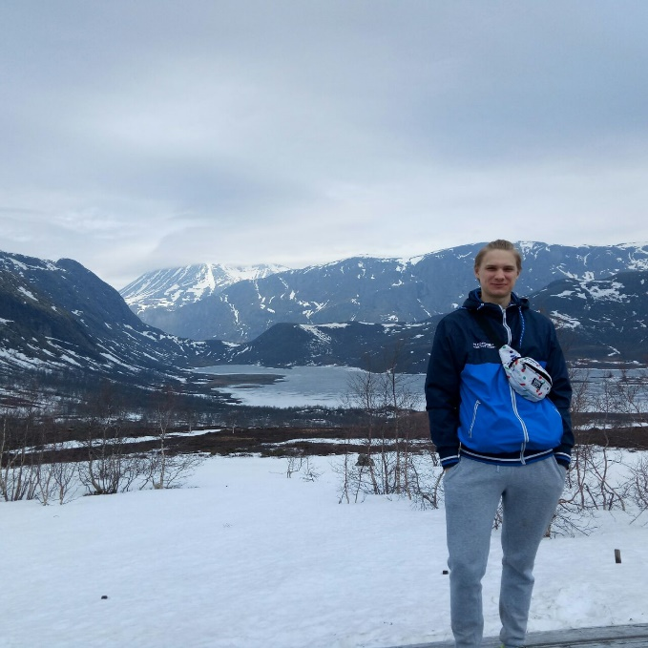
Despite the great diversity of students from all over the world, communication and new making new friends is easy, everyone is happy to meet new people.
The educational process is quite specific for student from Ukraine, since you acquire the bulk of knowledge by yourself. Despite the small number of classes, there is a lot to do while studying. At the lectures and practical classes, the atmosphere is very easy and friendly, the student can do anything he want at the lesson, what is more, attending lectures in the vast majority is not required, the mark is fully determined by the exam.
The educational process is diversified by various kind of excursions to the factories and reports from PHD and students, which makes lessons more interesting and practical.
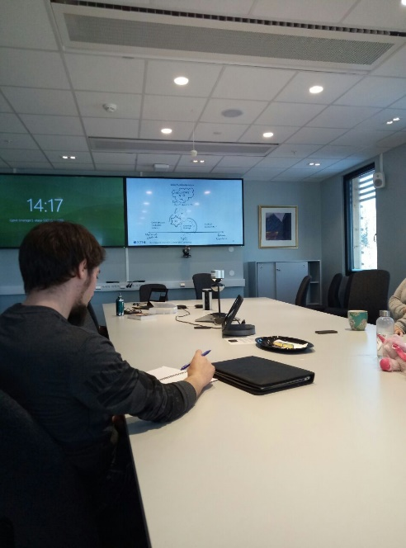
The university is very well-equipped, in each auditory there is a projector and a camera for recording a lecture, which, if you have such a need, can be viewed on a special internet resource.
It is also necessary to get used to the system of evaluation and receiving tasks, which are mainly carried out on Internet resources. The registration and constant monitoring of these resources, in my opinion, is extremely unusual and inconvenient for our students, but eventually, you get used to it.
For half a year in Norway and studying at NTNU, there was no unpleasant situation or difficulty that could not be overcome, but there was an incredible number of new acquaintances, positive impressions and interesting experiences what, in my opinion, proves that losing this opportunity will be a mistake for any student.
With best regards,
Holubenko Oleksandr.

